10.48: a) Since the gyroscope is precessing in a horizontal plane, there can be no net vertical force on the gyroscope, so the force that the pivot exerts must be equal in magnitude to the weight of the gyroscope, 1.62 N to three figures.
b) Solving Eq. (10.36) for 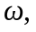
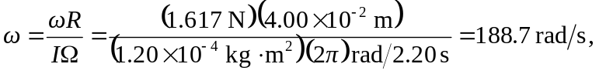
which is 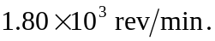 Note that in this and similar situations, since  appears in the denominator of the expression for 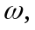 the conversion from 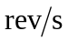 and back to 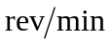must be made.

c)
